Feature 1: Accounts login

User Stories

* As a current user of this App, I want to go to main page, so I can play the game.

Acceptance Criteria

* Given that the login screen is being displayed, when username and password are entered properly and correctly, then the user should be navigated to main page (the user center).
* Given that the login screen is being displayed, when the “Not a user?” link is tapped, then the user should be navigated to user registration screen.
* Given that the login screen is being displayed, when the “Forget Password?” link is tapped, then the user should be navigated to recovering password screen.

Workflow **&** Paper Prototype

See the following figure for this feature.

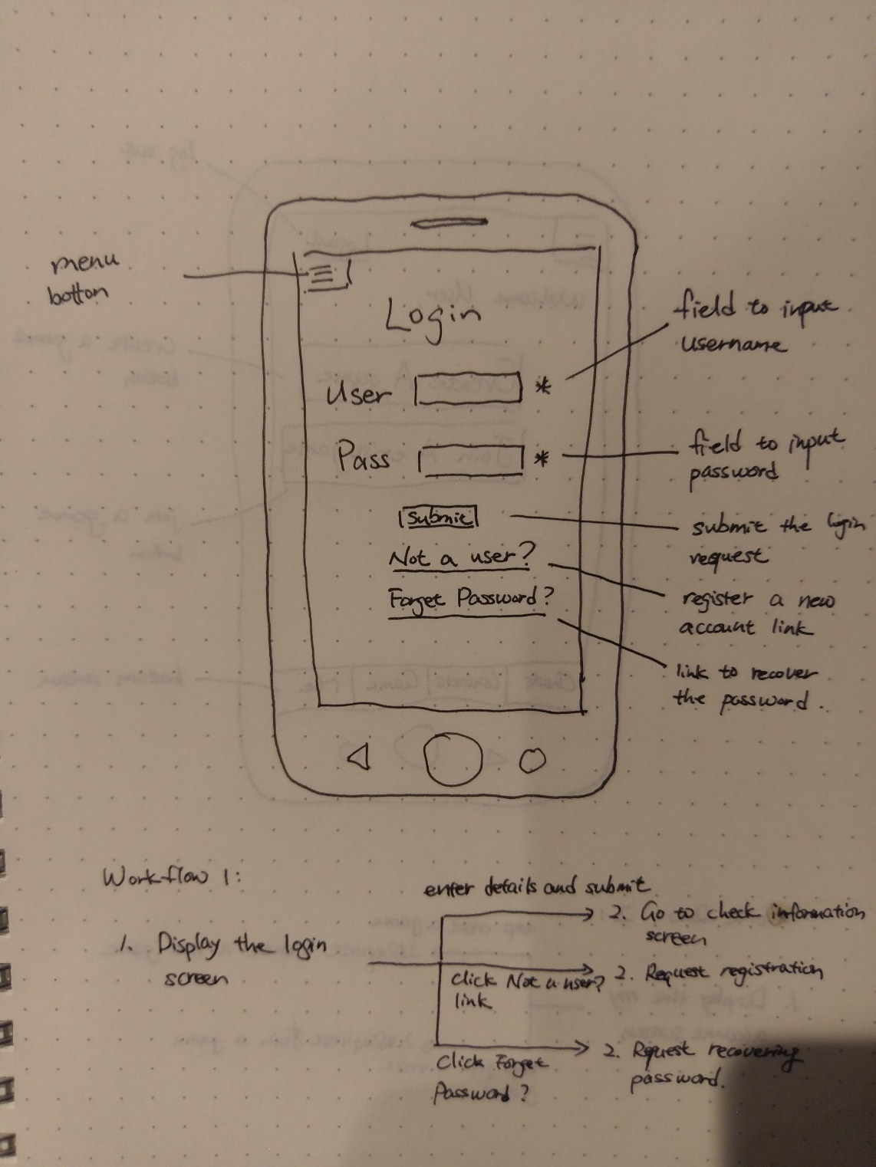

Specification

The view will show a login form containing username and password fields, a single submit button and two links. Pressing the submit button will check the information that user typed, if there is nothing wrong, then the main page will be displayed. The other two links will help user to create a new account or find their password.

Priority

*Core: Expected to achieve.*

Feature 2: Main page

User Stories

* As a current user of this App, I want to manage my account, so I can add new friends or start a new game.

Acceptance Criteria

* Given that the main screen is being displayed, when the user taps the “Create a game” button, then the user should be navigated to game creating screen.
* Given that the main screen is being displayed, when the user taps the “Join an exist game”, then the user should be navigated to game joining & searching screen.

Workflow **&** Paper Prototype

See the following figure for this feature.

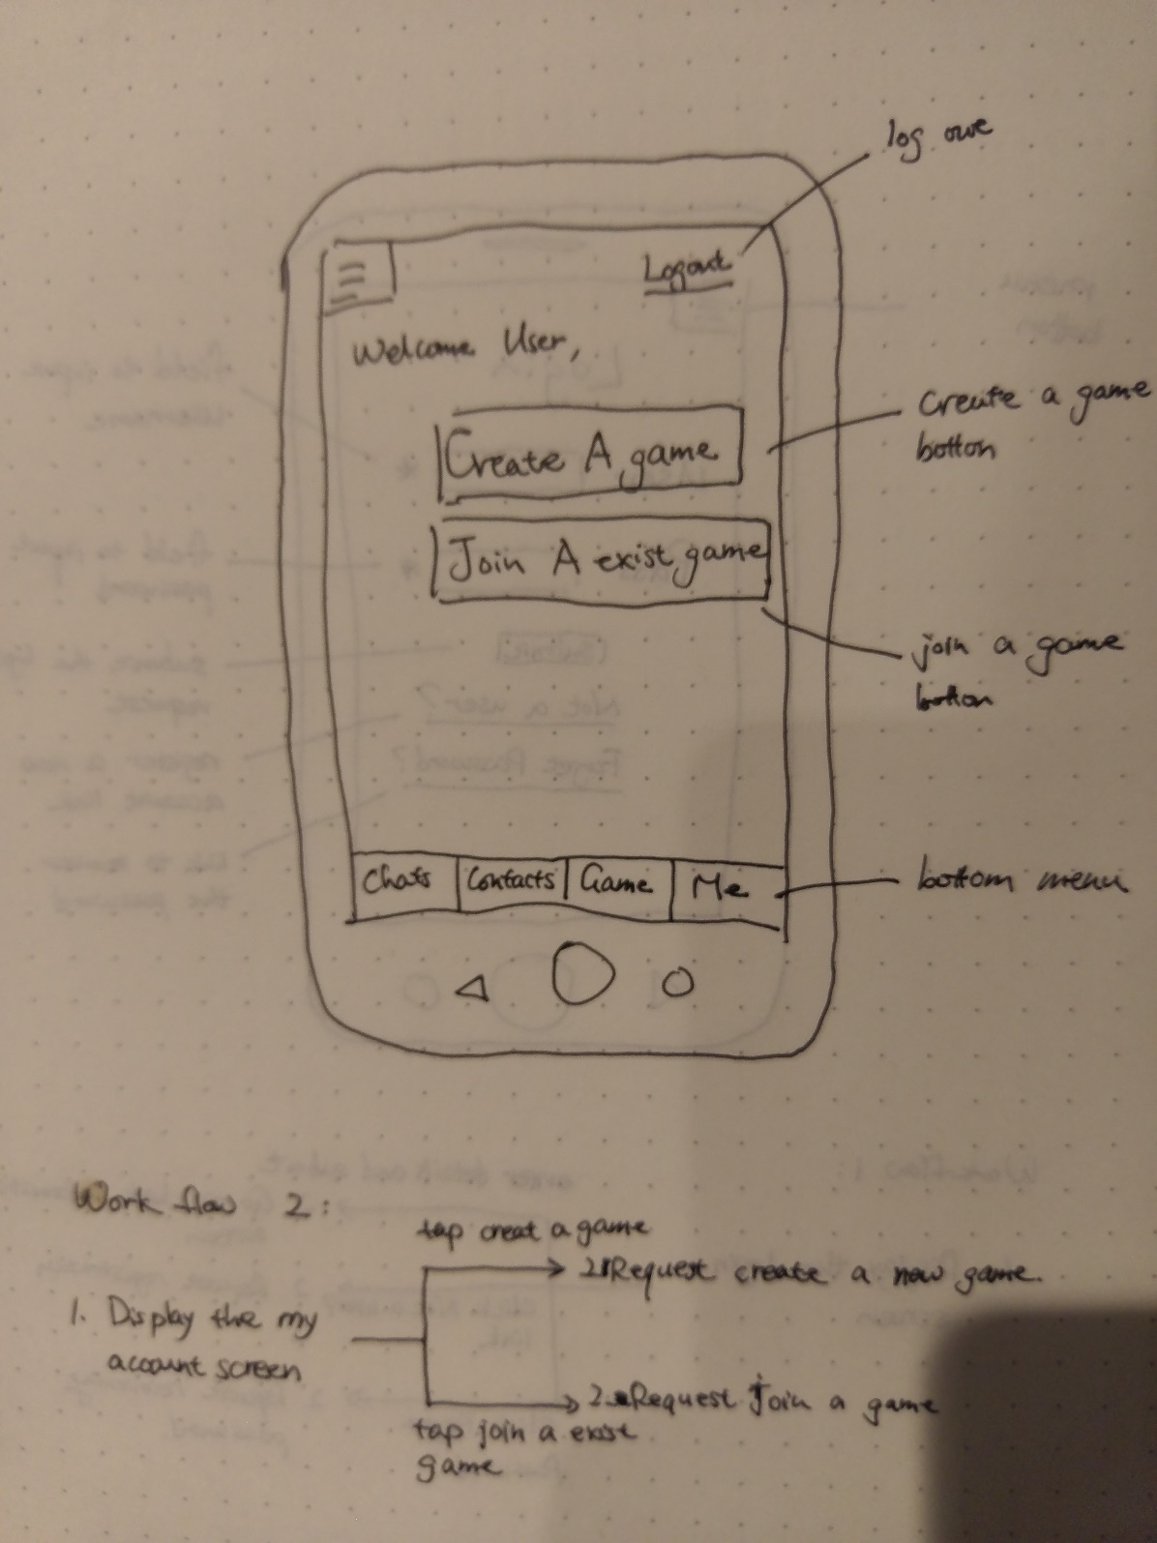

Specification

The view will show two single, large, buttons with the text “Create a game” and “Join an exist game” on them. Pressing the “Create a game” button will initiate a request for creating a new game. Pressing the “Join an exist game” button will display the join game page.

Priority

*Core: Expected to achieve.*

Feature 3: Create game

User Stories

* As a user, I want to start a new game, so that I can play with others.

Acceptance Criteria

* Given that the creating game screen is being displayed, when the user finished the settings and taps the “Start” button, then the user should enter the game that created using those settings and the user should be the owner of this game.

Workflow **&** Paper Prototype

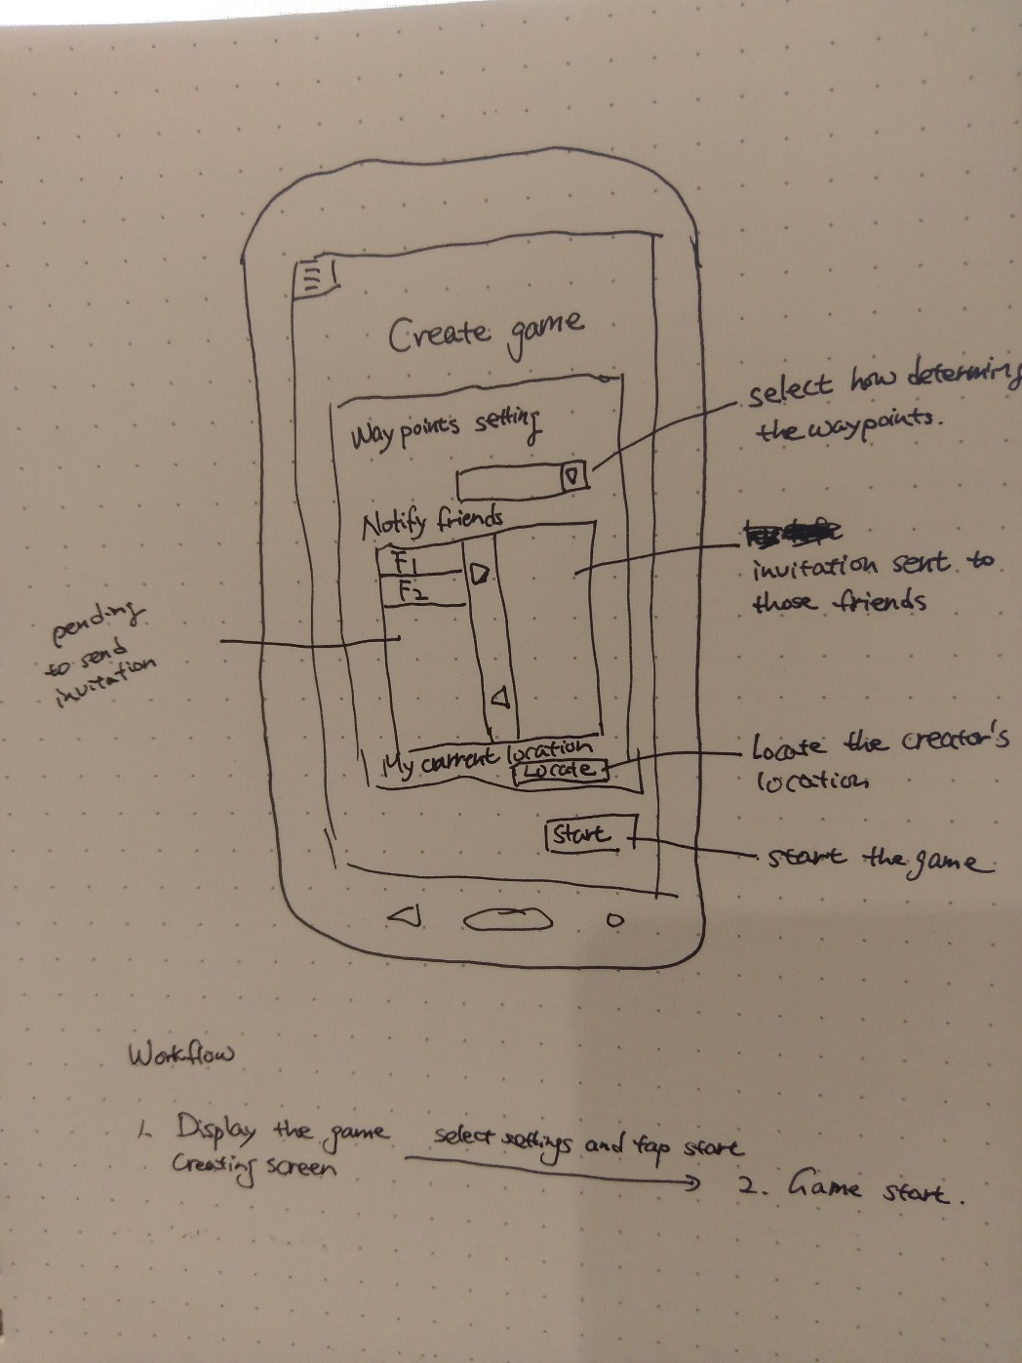

Specification

*Textual description of the feature that explains what it does and possibly why.*

*Include feature dependencies.*

Priority

*Core: Expected to achieve.*